GEORGETOWN UNIVERSITY
DEPARTMENT OF CLASSICS
SPRING 2019

LATIN 240

CICERONIAN ORATORY: INVECTIVE

MW 9:30 – 10:45 A.M. Zachary Herz, 318 Healy
Healy 321 zh149@@georgetown.edu
Office Hours: {TBD}

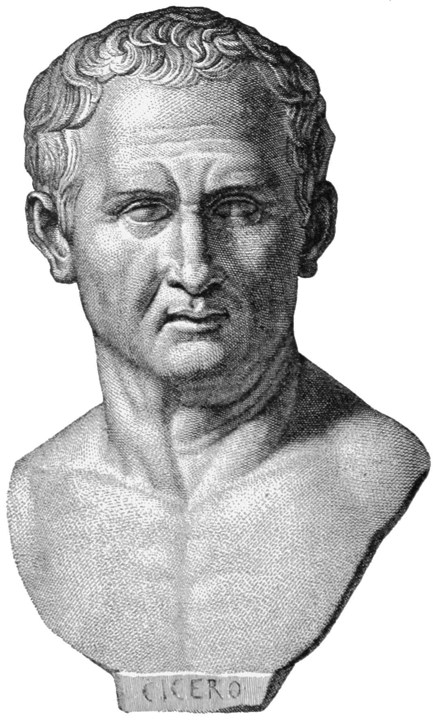

Bust of the orator Cicero. Image via Wikimedia Commons.

Course Description:

Marcus Tullius Cicero is widely considered the greatest orator in Roman history—a tireless advocate for democracy and the rule of law who fought to preserve the Rome he loved against the specter of empire. This class is not about that. Cicero was also one of the foremost practitioners of Roman invective, a ruthless insult comic who deployed every rhetorical trick available to highlight his targets’ violations of Roman norms. In this class, students will closely examine Ciceronian invective as both literature and history. Cicero’s attacks on figures like Catiline, Verres, and Marc Antony not only demonstrate the orator’s incredible facility with language but also the complex network of social expectations his opponents allegedly transgressed. Students will translate selections of Cicero’s most famous speeches with an eye towards understanding them as a literary product, and will also discuss the cultural and political context that made Cicero’s attacks so venomous. Students will be tested on this material with two translation-based exams and two papers.

Classes:

Class time will be spent primarily in translation. Students will be expected to arrive every day prepared to translate the day’s assignment. While I would rather students not bring written translations to class, I permit (and in fact encourage) grammatical notes and a vocabulary list. In addition to translation, we will discuss the historical context of Cicero’s speeches and the rhetorical devices he employs. Students will not only develop a greater facility with Ciceronian Latin and with Latin oratory in general, but will also learn how to research and write short papers on Cicero’s style and approach.

Assignments and Grading:

Students will demonstrate their translation skills in midterm and final exams, in addition to two short (3-5 page) literary papers. Grades will be calculated as follows:

Exams: 20% each
Papers: 20% each
Participation: 20%

I reserve the right to depart from this rubric in extraordinary circumstances, but rarely do so.

Classroom Conduct:

I expect students to remain attentive and respectful at all times, particularly of each other. I cold call, which means that I will ask you and your colleagues to speak extemporaneously; that can be challenging, and I expect all of you to help me create as comfortable a space for open dialogue as possible.

I strongly prefer that students not use personal computers in class. Students with electronic editions of texts may use an e-reader, but I will ask that any devices be disconnected from the internet during class time. Students who require laptops or other note-taking devices as a matter of accommodation should contact the Academic Resource Center (ARC).

Disability and Accommodation:

As a Georgetown student, you are entitled to reasonable disability accommodations under the Americans with Disabilities and Rehabilitation Acts. However, you also have strong privacy rights under the Family Educational Rights and Privacy Act, which forbids me from asking you questions about your medical history in order to evaluate an accommodations request. Like many universities, Georgetown has created a special office to address accommodation requests within ARC.

In order to receive disability-related academic accommodations, you must first be registered with ARC, who will walk you through the process of requesting accommodation. Please do not come to me directly with accommodation requests—I will gladly honor such requests from ARC, but cannot evaluate and accommodate students myself.

Academic Honesty:

I expect you to adhere to Georgetown’s Honor Code and am affirmatively responsible for reporting suspected infractions. If you plagiarize, I will catch you, and I am mean. That said, the rules around plagiarism and academic honesty are not always intuitive; if you are not sure how best to cite a source or what sort of attribution is appropriate, bring the source to office hours or make an appointment to discuss it. I’m happy to help you stay out of trouble.

Required Texts:

The following texts are available at the Georgetown University bookstore. If you prefer to save some money, or alternately to contribute to America’s once thriving and now critically endangered independent book sellers, mazel tov; however, please make sure you have purchased the most recent edition.

Dickison, Cicero’s Verrine Oration II.4. Wayne State University Press. ISBN: 9780814323823.
Philippics I-II. Cambridge Greek and Latin Classics (Green & Yellow). ISBN: 9780521422857.

Important Dates:

January 9: Introduction
January 14: Introduction to Cicero: The Verrine Orations

February 25: Midterm; first paper assigned

March 11: first paper due

April 10: second paper assigned

April 24: second paper due

May 4: Final Exam (9-11 A.M.)

