COLORADO UNIVERSITY BOULDER
DEPARTMENT OF CLASSICS
FALL 2019

LATN 3014

CICERONIAN INVECTIVE

MWF 11:00 – 11:50 A.M. Zachary Herz, 307 Woodbury
Ketchum 1B64 zachary.herz@colorado.edu
Office Hours: {TBD}

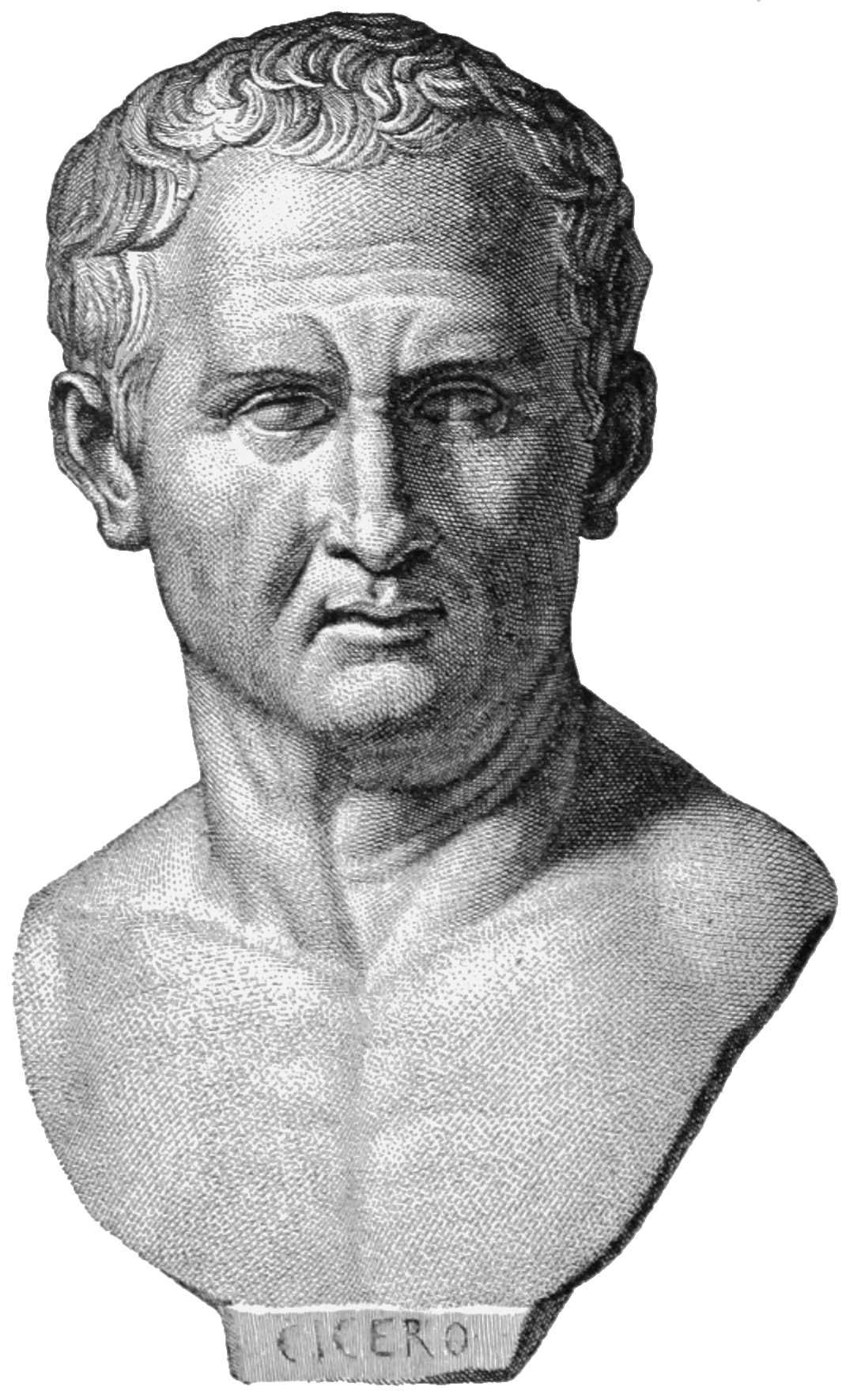

Bust of the orator Cicero. Image via Wikimedia Commons.
Course Description:

Marcus Tullius Cicero is widely considered the greatest orator in Roman history—a tireless advocate for democracy and the rule of law who fought to preserve the Rome he loved against the specter of empire. This class is not about that. Cicero was also one of the foremost practitioners of Roman invective, a ruthless insult comic who deployed every rhetorical trick available to highlight his targets’ violations of Roman norms. In this class, students will closely examine Ciceronian invective as both literature and history, through the lens of the Verrine Orations. Cicero’s attacks on the corrupt (likely), greedy (probably) and unmanly (maybe?) Gaius Verres not only demonstrate the orator’s incredible facility with language but also the complex network of social expectations his opponent allegedly transgressed. Students will translate selections of Cicero’s first major speech with an eye towards understanding them as a literary product, and will also discuss the cultural and political context that made Cicero’s attacks so venomous. Students will be tested on this material with two translation-based exams and two papers.

Required Text:

Dickison, Cicero’s Verrine Oration II.4. Wayne State University Press.

This book is available at the bookstore, but if you wish to purchase it elsewhere feel free: just make sure you have the most recent edition, since page numbers often change. Scholarly readings outside of this text will be posted to Canvas.

Classes:

Class time will be spent primarily in translation. Students will be expected to arrive every day prepared to translate the day’s assignment. While I would rather students not bring written translations to class, I permit (and in fact encourage) grammatical notes and a vocabulary list. In addition to translation, we will discuss the historical context of the In Verrem and the rhetorical devices it employs. Students will not only develop a greater facility with Ciceronian Latin and with Latin oratory in general, but will also learn how to research and write short papers on Cicero’s style and approach.

Assignments and Grading:

Students will demonstrate their translation skills in midterm and final exams, in addition to two short (3-5 page) literary papers. Grades will be calculated as follows:

Exams: 20% each
Papers: 20% each
Participation: 20%

Classroom Conduct:

I expect students to remain attentive and respectful at all times, particularly of each other. I cold call, which means that I will sometimes call on students who have not raised their hands; that can be challenging, and I expect all of you to help me create as comfortable a space for open dialogue as possible.

The use of electronic devices in class (personal computers, tablets, etc) is strictly forbidden; it is vital that you be fully engaged and present, and electronic devices hinder that engagement. If you have learning provisions that require the use of certain technologies, please let me know so that we can come to an arrangement.
Office Hours:

Every {day} from {time to time}, I will be in my office (Woodbury 307) with the door open. I do this so that you can come by and talk to me about the class in a relaxed setting; whether you need help with something, have a question about the class, or simply want to talk more about the reading. Please come! You are always welcome to come to my office hours, and I appreciate the company. If you want to meet with me and are not free during my office hours, e-mail me at zachary.herz@colorado.edu and we can choose another time and place.

Important Dates:

August 26: Introduction

October 7: Midterm; first paper assigned

October 28: First paper due

November 18: Second paper assigned

December 9: Second paper due

December 15: Final Exam (1:30 – 4:00 P.M.)

