GEORGETOWN UNIVERSITY
DEPARTMENT OF CLASSICS
SPRING 2019

C L A S S I C S 1 3 5 : T H E R I S E O F R O M E

TTh 9.30-10.45 AM Zachary Herz, 318 Healy
Maguire 101 zh149@georgetown.edu
Office Hours: {TBA}

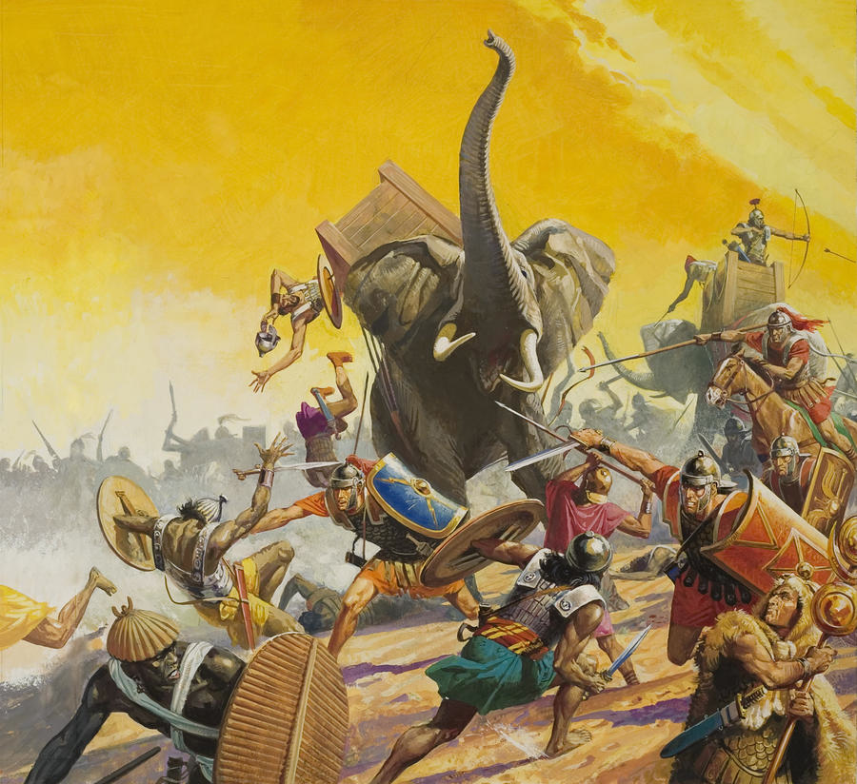

“In its broad outline, the destiny of Rome is devastatingly simple.
Viewed from close up, people, events, and details complicate the story.”
--Fernand Braudel

Course Description:

When Alexander the Great died in 323 B.C.E., his successors inherited a fractious, complex, and wildly heterogeneous political order stretching from the Central Mediterranean to Central Asia. This course examines that order, its collapse over the next two three centuries, and the rise of the next great power to rule the Mediterranean basin—the Roman Republic. Students will learn about the various cultures that made up the Hellenistic world, as well as the early history of the state that would come to rule that world; students will end the course with a working knowledge of both Hellenistic and early Roman political and cultural history. In addition, students will learn to think critically about problems of method and the impact of conquest on the historical record. Students will be tested on this material in two exams and a short paper.
Classes:

Class will be a mixture of lecture and discussion, weighted towards the former. Regardless, students are expected to arrive every day prepared to discuss questions and methodological problems raised by the reading. I cold call, which means that I reserve the right to call on students and ask them to discuss the day’s reading; I think that speaking extemporaneously is an important skill. However, I will try to be respectful and encouraging in these interactions and I require all of you to do the same; support each other or taste my wrath.

Assignments and Grading:

Students will be graded on participation, in addition to a midterm exam and two papers. Grades will be calculated as follows:

Midterm: 20%
Final: 30%
Paper: 30%
Participation: 20%

I reserve the right to depart from this rubric in extraordinary circumstances, but rarely do so.

Classroom Conduct:

I strongly prefer that students not use personal computers in class. Students with electronic editions of texts may use an e-reader (preferred) or laptop, but I will ask that any devices be disconnected from the internet during class time. Students who require laptops or other note-taking devices as a matter of accommodation should contact the Academic Resource Center (ARC).

Disability and Accommodation:

As a Georgetown student, you are entitled to reasonable disability accommodations under the Americans with Disabilities and Rehabilitation Acts. However, you also have strong privacy rights under the Family Educational Rights and Privacy Act, which forbids me from asking you questions about your medical history in order to evaluate an accommodations request. Like many universities, Georgetown has created a special office to address accommodation requests within ARC.

In order to receive disability-related academic accommodations, you must first be registered with ARC, who will walk you through the process of requesting accommodation. Please do not come to me directly with accommodation requests—I will gladly honor such requests from ARC, but cannot evaluate and accommodate students myself.

Academic Honesty:

I expect you to adhere to Georgetown’s Honor Code and am affirmatively responsible for reporting suspected infractions. If you plagiarize, I will catch you, and I am mean. That said, the rules around plagiarism and academic honesty are not always intuitive; if you are not sure how best to cite a source or what sort of attribution is appropriate, bring the source to office hours or make an appointment to discuss it. I’m happy to help you stay out of trouble.

Required Texts:

The following texts are available at the Georgetown University bookstore. If you prefer to save some money, or alternately to contribute to America’s once thriving and now critically endangered independent book sellers, mazel tov; however, please make sure you have purchased the most recent edition.

Cicero, Defense Speeches. Oxford. ISBN: 0199537909.
Fox, The Classical World: an Epic History from Homer to Hadrian. Basic Books. ISBN: 0465024971.
Plutarch, The Age of Alexander. Penguin, rev. ed. 2012. ISBN: 0140449353.
Plutarch, Plutarch on Sparta. Penguin, rev. ed. 2005. ISBN: 0140449434.
Plutarch, The Makers of Rome. Penguin. ISBN: 0140441581.
Polybius, The Rise of the Roman Empire. Penguin. ISBN: 0140443622.
Shaw, Spartacus and the Slave Wars: a Brief History with Documents. Bedford/St. Martin’s. ISBN: 0312183100.

Schedule of Class Meetings and Reading Assignments:
* CW = Lane Fox, The Classical World

Th 10 January 1. Introduction

T 15 January 2. Macedon: Birthplace of Alexander and His Empire
reading: CW pp. 184-93 (“Philip of Macedon”) Plutarch, Alexander chapters 1-16
(pp. 279-296 in The Age of Alexander)

Th 17 January 3. Alexander’s Empire
reading: CW pp. 221-32 (“Alexander the Great”); Plutarch, Alexander chapters 17-77
(pp. 296-361 in The Age of Alexander)

T 22 January 4. The New Kings
reading: CW pp. 233-44 (“Alexander’s Early Successors”); Plutarch, Demetrius
(pp. 404-53 in The Age of Alexander)
Th 24 January 5. Alexandria and Royal Patronage
reading: CW pp. 245-55 (“Life in the Big Cities”), pp. 256-65 (“Taxes and Technology”), and pp. 266-74 (“The New World”); selections from the archives of Zenon (Canvas)

T 29 January 6. Gymnasiums, Theaters, and Greek Cultural Life
reading: review CW pp. 266-74 (“The New World”); Menander, Samia (Canvas)

Th 31 January 7. Macedonia and ‘Old Greece’: the Tragedy of the Leagues
reading: F. W. Walbank, The Hellenistic World pp. 79-99 and 152-58 (Canvas); Federalist Papers nos. 15 and 18 (Canvas)

T 5 February 8. Rich and Poor: the Economy and Politics
reading: Plutarch, Agis and Cleomenes (pp. 81-131 in Plutarch on Sparta); CW pp. 65-74

Th 7 February 9. The Revolt of the Maccabees: Jews in the Hellenistic World
reading: F. W. Walbank, The Hellenistic World pp. 222-26; Selections from 1 Maccabees (Canvas)

T 12 February MIDTERM EXAM (covering material through Thursday 7 February)

Th 14 February 10. Western Horizons: Rome, Greek Italy, and Carthage
reading: CW pp. 104-14, 275-87, and 295-301; Plutarch, Pyrrhus chapters 13-25
(pp. 475-93 in The Age of Alexander)
***PAPER ASSIGNED***

Th 21 February 11. Who Were the Gods of Rome?
reading: CW pp. 288-94; evidence for the Roman calendar and Roman festivals (Canvas)

T 26 February 12. Tempest over Sicily: the First Punic War and its Aftermath
reading: review CW pp. 295-301; Polybius 1.1-37 (pp. 41-82 in The Rise of the Roman Empire)

Th 28 February 13. Did Republican Rome have a ‘Mixed Constitution’?
reading: Polybius 6 (pp. 302-52 in The Rise of the Roman Empire)

T 12 March 14. Hannibal against Rome
reading: CW pp. 302-310; Polybius 3.17 and 33-118
(pp. 194-95 and 209-76 in The Rise of the Roman Empire)

Th 14 March 15: Imperium: the Spread of Roman Power
reading: CW pp. 311-18; texts and documents illustrating the spread of Roman power in the Eastern Mediterranean (Canvas)

T 19 March 16. Cultural Aspirations and Anxieties: Greek Civilization and Rome
reading: CW pp. 321-29; Plautus, Casina (Canvas)

Th 21 March 17. The Struggle for Reform
reading: CW pp. 330-40; Plutarch, Tiberius Gracchus (pp. 153-74 in Makers of Rome)

T 26 March 18. Gaius Gracchus: the Comprehensive Reformer
reading: review CW pp. 330-40; Plutarch, Gaius Gracchus (pp. 175-93 in Makers of Rome); the Acilian Law on Extortion (Canvas); quotations from speeches of Gaius Gracchus in Aulus Gellius (Canvas)

Th 28 March 19. Civil War: Imperium Turns against Itself
reading: review CW pp. 330-40; selection from H. J. Haskell, This Was Cicero (Canvas); Cicero, Pro Roscio Amerino 1-54 and 124-55 (pp. 9-25 and 47-58 in Defense Speeches)
***PAPER DUE***

T 2 April 20. The Stuck Elephant: Rome between Republic and Empire
reading: CW pp. 341-60; Cicero, On the Command of Pompey 1-19, 27-48, 59-71 (Canvas); Cicero, Letters to his Friends 7.1 (Canvas)

Th 4 April 21. Spartacus and Slave Rebellion
reading: Shaw, Spartacus and the Slave Wars: a Brief History with Documents pp. 33-68, 79-86, 108-15, and 131-44

T 9 April 22. The World of Cicero
reading: review CW pp. 351-60; selections from Cicero, Tusculan Disputations, “Brave Men Despise Death” and On Duties, “Ethics of a Salesman” (Canvas); Ciceronian letters on domestic design and a domestic quarrel (Canvas); Cicero, Pro Caelio 1-14, 25-42, and 51-69 (pp. 129-34, 138-46, and 148-57 in Defense Speeches)

Th 11 April 23. The Three-Headed Monster
reading: CW pp. 361-81; selections from Cicero’s letters from the early 50s BCE (Canvas)

T 16 April 24. The Dictatorship of Julius Caesar
reading: CW pp. 382-94; judgments on Caesar by Cicero, Matius, Sallust, and Sulpicius Galba (Canvas)

T 23 April 25. “The Last of the Romans”: the End of Republican Government
reading: CW pp. 395-403; Cicero, Second Philippic 25-36 and 118-19 (Canvas); Plutarch, Brutus (pp. 223-70 in Makers of Rome)

Th 25 April 26. “The Bright Day is Done”: the End of the Hellenistic World
reading: CW pp. 407-17; Plutarch, Antony 1-36 and 53-87 (pp. 271-304 and pp. 319-49 in Makers of Rome)

T 30 April 27. Final Review

